**Islamabad:**

Daman-e-Koh

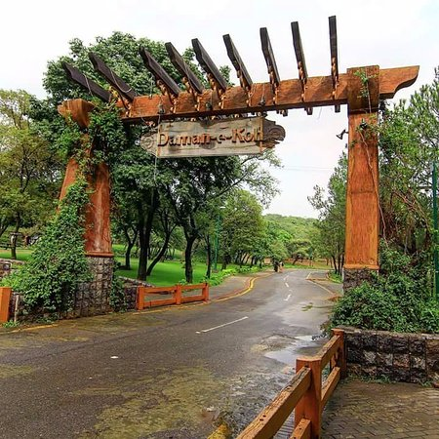

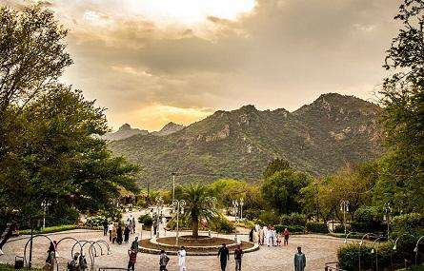

**Daman-e-Koh** is a viewing point and hill top garden north of Islamabad and located in the middle of the Margalla Hills. Its name is a conjunction of two Persian words, which together means foot hills. It is about 2400ft from sea level and almost 500ft from the city of Islamabad. It is a popular destination for the residents as well as the visitors to the capital. Daman-e-Koh is a midpoint for tourists on their way to the higher view point Pir Sohawa which is located at the top of Margalla Hills at an elevation of about 3600ft. There is a plan to construct a chairlift from Daman-e-Koh to Pir Sohawa. Monkeys are a common sight during winter. Cheetahs are frequently reported to descend from higher hills of Murree during snowfall.